 | Abdi İpekçi Cad, Kaşıkçıoğlu Apt. No:42 D:2  34365 Nişantaşı, İstanbul  www.artxist.com info@artxist.com  T. +90 212 291 77 84 F. +90 212 343 69 35 | PRESS RELEASE

x-ist is participating in ArtInternational - taking place in Haliç Congress Center for the second time- between 26-28 September, 2014.

x-ist @ ArtInternational 14

Booth No: A12

ArtInternational is hosting 80 international galleries from 24 different countries and only 12 of the galleries are Turkish. Located in the booth A12, x-ist exhibits works by Ansen, Ceren Oykut, Ekin Saçlıoğlu, Seda Hepsev, Erkut Terliksiz and Emin Mete Erdoğan.

Ansen's works produced with the "anaglyph 3D" technique will be exhibited for the first time in this fair. These works, which will be displayed in a special section of the x-ist booth- can be viewed both by the bare eyes of the visitor and with 3D glasses. Utilizing the latest developments in technology; Ansen positions the viewer as a witness to the plot. Some of the details and the clues to the story, which is based on the satirical relationship between the arts and capital in the modern art world, can only be discovered within the three dimensions.

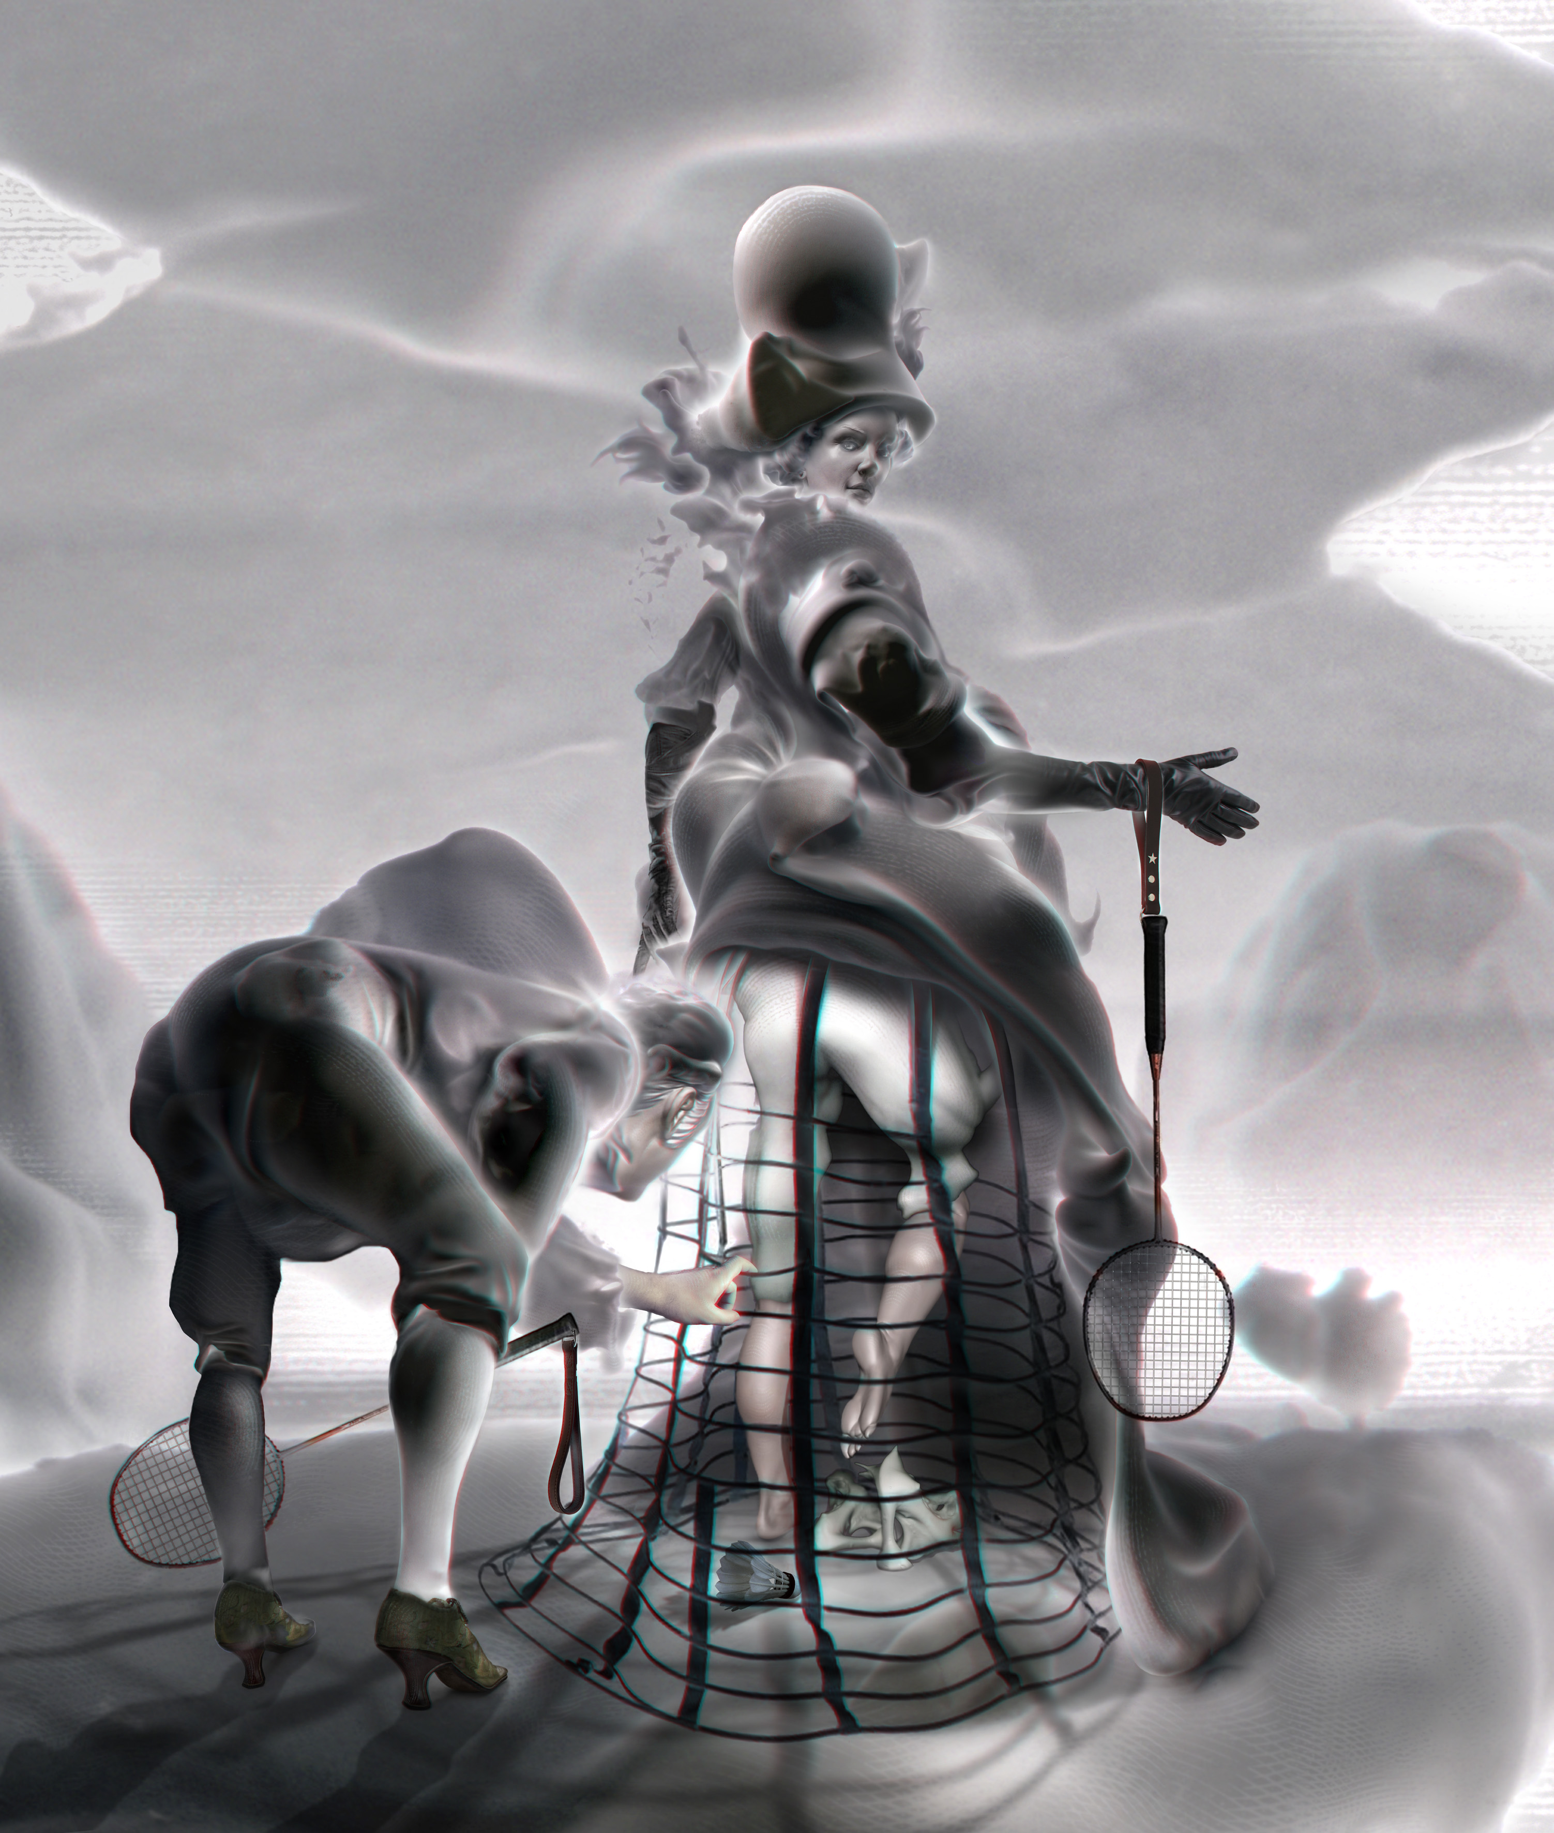

Ansen, Ins and Outs, Digital monoprint with 3D mapping, 125 x 106 cm, 2014
Emin Mete Erdoğan, an artist aiming to combine technical drawing with classical painting, plots scenes that are influenced by technology with god-like perfectionism. By adding an element of mobility to his intertwined structures, Emin Mete Erdoğan takes the viewer to a space without any hint of time in order to let them discover an infinite texture and to question their own perception. In addition, Erdoğan's recent works produced on aluminum can be seen for the first time in thisfair.

Erkut Terliksiz is aiming to establish a relationship between nature and mind in his grotesque and narrative works based on dailylife events. His works resembling fairy tales and consisting of alternative portraits blended with animal figures harbour primitive feelings . His experimental material use, which Terliksiz focuses more on in the recent years, stands out in these works. The artist uses any found material as a surface and most of the time adds another dimension to them creating sculptural paintings.

In the works produced for ArtInternational, Seda Hepsev transfers the daily moments collected in her personal memory via photography on to the canvas. The very short moments represented in the works extend to hours and days during the production process; thus creating a different experience and tension for the artist.

Ekin Saçlıoğlu presents two new works of seemingly joyful landscapes, but with elements of unrest and disharmony. The viewers' perceptions vary as they observe these paintings resembling movie scenes.

Ceren Oykut, an artist combining cartoon with drawing, depicts the ever-changing urban life with symbols and tales inspired by personal experience. Oykut recreates the chaos in the city in two wall-sized drawings that spread over the floor as well.

This year, x-ist's booth is right next to the lecture hall where artist talks organized by SPOT takes place.

Please contact to Ece Göymen from x-ist for further information.
ece@artxist.com
M. 537 349 13 27
T. 212 291 77 84

